CENE 476 Capstone Proposal

December 13, 2016

**Team Flaming Bunnies** (2016-2017)

**Prepared by:**

Brando Gutierrez

Gabe Green

Skylar Clemons

**Prepared for:**

Dr. Wilbert Odem, Ph.D., P.E.

Tom Runyon, Hydrologist for Coconino Forest Service

Table of Contents

1.0 Project Understanding 1

***1.1* Project Purpose** 1

***1.2* Project Background** 1

***1.3* Technical Considerations** 1

***1.4* Potential Challenges** 1

***1.5* Clients and Stakeholders** 2

2.0 Scope of Services 2

Task 2.1.0 Research 2

2.1.1 Laws governing wetlands 2

2.1.2 Chemical additives to soil 2

2.1.3 Other similar wetland problems 2

2.1.4 Wetland vegetation 3

Task 2.2.0 Field Work 3

2.2.1 Surveying the project site 3

Task 2.3.0Geotechnical work 3

2.3.1 Soil sample gathering and identification 3

2.3.2 Soil profile of the wetland 3

2.3.3 Moisture content and organic content 3

2.3.4 Hydraulic conductivity and analysis 3

2.3.5 Soil test pits of undisturbed clay, disturbed clay, and clay loam 4

2.3.6 Compaction specifications and development 4

Task 2.4.0Design Alternative Development 4

2.4.1 Design alternatives 4

2.4.2 Alteration of existing clay or soils at project site 4

2.4.3 Seeding and mulching impacted areas with native plants 4

Task 2.5.0 Project Management 5

2.5.1 Project meetings with client 5

2.5.2 Project schedule 5

2.5.3 Project meetings with technical advisor 5

2.5.4 Final design report 5

2.5.5 Final design presentation 5

2.5.6 Website 5

Exclusions 6

3.0 Scheduling 6

***3.1* Gantt Chart** 6

***3.2* Critical Path** 6

***3.3* Meetings** 6

4.0 Staffing and Cost of Engineering Services 6

4.1 Staff plan for Allan Lake Wetland Restoration Project 6

4.2 Cost and billing rate for Allan Lake Wetland Restoration Project 7

References 9

Appendices 10

**Appendix A** 10

**Appendix B-** 11

**Appendix C** 12

# 1.0 Project Understanding

### **1.1 Project Purpose**

The Allan Lake Wetland Restoration project aims to restore the historical wetlands’ ability to retain water and support wetland vegetation. The fine particle clay layer that had acted as an impermeable water holding layer has been disturbed resulting in a loss of wetland function. The purpose of this project is to improve the distribution and retention of water in the wetland area.

### **1.2 Project Background**

Allen Lake is located 2.7 miles north of the intersection of Lake Mary Road and Stoneman Lake Road, along Lake Mary Road where it can be seen in Appendix A (Latitude 34º 49’ 34.09” N, Longitude: 111 º 26’ 27.45’’ W). Currently the lake is a series of ditches surrounding a grassy field, as shown in the Appendix B. This is the result of a failed effort to improve waterfowl habitat in 1986 involving explosives and earthmoving equipment. One small section of the lake has undergone a restoration and there are obvious differences in vegetation that can be seen in Appendix C.

### **1.3 Technical Considerations**

The following subsequent sections will outline the technical work that needs to be done for this project:

*1.31* Surveying the project site.

*1.32* Developing a topographic map based of the surveying data points

*1.33* Compiling a cut and fill estimations of the surveyed site

*1.34* Earthworks.

1.34a Removing, replacing, and altering existing clay or soils at project site

1.34b Seeding and mulching impacted areas with native plants

*1.35* Geotechnical work and testing

1.35a Soil sampling and testing for moisture content and organic content

1.35b Hydraulic conductivity and analysis

1.35c Soil test pits of undisturbed clay, disturbed clay, and clay loam

1.35c1 Percolation and infiltration tests

1.35d Compaction specifications and development of soil samples

1.36 Policies and laws governing wetlands in the United States

1.36a Research policies and laws protecting waterfowl, wetlands, and plants

### **1.4 Potential Challenges**

The catchment area draining to Allan Lake accumulates significant snow pack during the winter which melts in the spring creating saturated conditions within the wetland until late April or early May. This situation requires that field work to be accomplished prior to the first snowfall. Delaying field work after the first snowfall would be problematic for surveying and soil testing. We will address this problem by doing as much fieldwork as possible before the first major snow storm. Additionally, any governing laws that protect wetlands in the United States may impact the kind of design or remediation efforts needed to complete the project. We must research laws and policies of wetlands in order to propose a project idea that is acceptable by the U.S. Forest Service.

### **1.5 Clients and Stakeholders**

Our client is the United States Forest Service (USFS). Tom Runyon is our secondary client who is a coordinator hydrologist for the Coconino National Forest. Our stakeholders are the species and plants of the wetland, people who own land adjacent to the impacted areas, Arizona Game and Fish, and the general public who has unrestricted access to the site.

# 2.0 Scope of Services

The Allan Lake Wetland Restoration project aims to restore the historical wetlands’ ability to retain water and support wetland vegetation. The fine particle clay layer that had acted as an impermeable water holding layer has been disturbed resulting in a loss of wetland function. The purpose of this project is to improve the distribution and retention of water in the wetland area. The proposal that is mentioned throughout this document refers to the design report that will be created if Team Flaming Bunnies (TFB) is awarded with the contract to restore the Allan Lake Wetland. The following subsequent sections will outline the scope of work that needs to be done for this project:

## **Task 2.1.0 Research**

### 2.1.1 Laws governing wetlands

The site exists on National Forest land which is indicative of the many regulations and policies regarding the protection of wetlands. These laws that protect and govern wetlands must be understood and identify in order for team to progress forward with design solutions. Federal and state laws are the most important to the project, and as part of the proposed design the laws will be listed along with what is impacted in the design criteria.

*Deliverable: List of governing laws and policies.*

### 2.1.2 Chemical additives to soil

Some chemical additives have the potential to reduce the hydraulic conductivity of soil. Due to the size of the project, the team will research chemical additives as an option to reduce the cost of the project. Depending on the results of the research they may be used in geotechnical experiments that will inform our design recommendations.

*Deliverable: Documentation of chemicals researched and tested.*

### 2.1.3 Other similar wetland problems

Other wetlands in Northern Arizona have the same problem as Allan Lake, a clay layer that has been disturbed by using excavation methods. The work done at Allen Lake will also serve as a model for other wetlands such as, Duck Lake, Deep Lake, Blind Lake, Horse Lake, Fisher Lake, and Fry lakes.

*Deliverable: Suggested remediation for other areas*

### 2.1.4 Wetland vegetation

The plant species that currently exist at Allen Lake are typical upland plants and grasses. This is contrary to the Allan Lake’s previous vegetation prior to the excavation. Native vegetation for wetlands will be researched. This research will allow the team to make an informed recommendation for the plant diversity that at Allan Lake.

*Deliverable: List of native plants that should exist at Allan Lake*

## **Task 2.2.0 Field Work**

### 2.2.1 Surveying the project site

Utilizing NAU’s survey equipment (Total Station, steaks, prism rods, etc.) for collecting data points and creating a topographic map. The map will be useful for later in the project when design solutions are under consideration. A Global Positioning System (GPS) will also be used to gather points at Allan Lake. Kit McDonald, a soil expert for the Forest Service will provide the GPS for the team.

### *Deliverable: Point list and topographic map.* 2.2.2 Soil sample gathering and identification

Utilizing soil augers will help to develop a soil profile at selected sampling sites at Allan Lake. Also, the soil dug up by the soil augers will be collected for soil testing. Soil samples will be gathered from the highest elevation at the lake to a depth not exceeding 3 feet below the bottom of the lowest trench.

*Deliverable: 10 to 15 soil samples collected.*

### 2.2.3 Soil test pits of undisturbed clay, disturbed clay, and clay loam

Percolation and infiltration tests will be conducted at sites where it is apparent that undisturbed clay, disturbed clay, and clay loam exist.

*Deliverable: Documentation of infiltration rates of each test pit.*

### 2.2.4 Soil profile of the wetland

Based upon the soil samples gathered at the lake a full soil profile will be developed and used when considering design alternatives. This soil sample will extend from the ground surface at the lake to 8 feet below grade.

*Deliverable: Soil profile* identified and documented.

## **Task 2.3.0Geotechnical work**

### 2.3.1 Moisture content and organic content

Use ASTM D2974 as a standard method for laboratory testing the organic and moisture content of soil samples.

*Deliverable: A spreadsheet of known values corresponding to where they were sampled.*

### 2.3.2 Hydraulic conductivity and analysis

Using ASTM D5084- section 16a to conduct the hydraulic conductivity of each of the soils samples.

*Deliverable: A spreadsheet of known values corresponding to where they were sampled*

### 2.3.3 Compaction specifications and development

Using ASTM 698: Proctor Compaction, a compaction curve will be developed that will help determine soil compaction properties such as the optimal water content at which soil can reach its maximum dry density. Also, ASTM D4318-10E1 will identify the liquid limit, plastic limit, and plasticity index which will help to identify an optimal compaction specification for the conditions existing at the site.

*Deliverable: Final submittal of the design to client and technical advisor*

## **Task 2.4.0Design Alternative Development**

### 2.4.1 Design alternatives

A suite of design alternatives will be developed for Allan Lake. Preliminary ideas include filling the trenches with the soil adjacent to the trenches to harvesting clay from another wetland area to restore Allan Lake’s ability to function as a wetland. The team will evaluate these design alternatives during the spring semester to determine which would be most effective for the site. The design alternatives will be analyzed based on a cost analysis for each of the proposed design.

*Deliverable: Final submittal to client and technical advisor*

### 2.4.2 Alteration of existing clay or soils at project site

Based on the findings of our field work and geotechnical work, recommendations will be given regarding soil modification at the site. This could include the development of a cut and fill estimate, compaction requirements, moisture requirements, a suggested time period when work should be completed, and various other components. The team will not perform any earthworks. Instead, recommendations will be provided in regards to the best solution possible.

*Deliverable: Design solution for soil remediation in submittal to client*

### 2.4.3 Seeding and mulching impacted areas with native plants

The team will provide a list of native plant species that should be present specifically for Allan Lake. The final proposal will describe alternatives in regards to how native plants should be introduced back to the wetland.

*Deliverable: Recommended remediation for vegetation in submittal to client*

## **Task 2.5.0 Project Management**

### 2.5.1 Project meetings with client

Team Flaming Bunnies (TFB) will conduct 3 to 6 meetings with Tom Runyon. These meetings will be used to clarify technical issues with the project, to provide the client with project updates and progress, and resolving project issues. These project meetings will serve as the primary forum for the client to review the status of the project and to address any concerns.

*Deliverables: Meeting Minutes*

### 2.5.2 Project schedule

To ensure that the expected work is being completed in a timely manner TFB will develop a schedule for the project. This schedule will be shared with the client and grader, and is based upon this scope of services.

*Deliverable: Project Schedule (Gantt Chart)*

### 2.5.3 Project meetings with technical advisor

As part of the project Gary Slim has agreed to be our technical advisor. He has knowledge regarding soils mechanics. Project meetings with Gary Slim will take place monthly or more if needed.

*Deliverable: Meeting Minutes*

### 2.5.4 Final design report

The final design report will be prepared during the spring semester, and will include all recommendations regarding a final design solution for Allan Lake.

*Deliverable: Final Design Report*

### 2.5.5 Final design presentation

To convey the information gathered and prepared into a report, TFB will present to the client, grader, and all other interested parties at the end of the spring semester.

*Deliverable: Final Design Presentation*

### 2.5.6 Website

A website will be created in order to showcase Allan Lake.

*Deliverable: Allan Lake Restoration Website*

## **Exclusions**

There are only a few exclusions for this project. The following tasks below pertain to the work that will not be done by TFB.

* The Forest Service will submit documents pertaining to the requirements environmental of the project.
* Construction management and construction
* Hydraulic Model and Analysis
* Permitting
* Earthworks: Earthmoving and Compaction
* Native Plant remediation
* Meetings outside of those outlined in this scope of work

# 3.0 Scheduling

### **3.1 Gantt Chart**

The GANNT Chart is a common tool that engineers and other professionals utilize in order to plan for projects. The GANNT chart uses a combination of an organized table to show the task and the dates from which the task will be worked on. The chart also uses a graphical representation that can easily illustrate which tasks will take the most time complete. To view the Allen Restoration GANTT chart, which contains information about the duration of each task to complete turn to appendix D. However, it should be noted that the schedule is subject to change depending on how long each task actually takes vs. the estimated time.

### **3.2 Critical Path**

The critical path is similar to the GANTT chart however, the sub tasks for each of the main tasks are removed to illustrate the main tasks that need to be completed in order to move to the next task. For example, to move to task 2.0, task 1.0 must first be completed. To view the teams critical path chart, turn to appendix D. The red tasks highlight the order of steps to be completed for this project.

### **3.3 Meetings**

For consistency, team Flaming Bunnies will meet every Friday after classes to discuss project direction and progress. This weekly meeting ensures that the project will continue to move forward and will make each member accountable for doing their weekly work. However, due to the amount of work required, the weekly meetings will be times for the students to plan to meet for additional meetings and work sessions, in order to complete the tasks on schedule.

# 4.0 Staffing and Cost of Engineering Services

## **4.1 Staff plan for Allan Lake Wetland Restoration Project**

The following table will outline the personnel necessary to complete the project:

**Table 4.1.1:** Staff and classification of expertise.

|  |  |
| --- | --- |
| Classification | Code |
| Project Engineer | PENG |
| Engineer | ENG |
| Geotechnical Technician | GEO |
| Surveyor | SUY |
| Administrative Assistant | AA |
| Engineering Intern | INT |

The following table will outline the task associated with the staff and hours necessary to complete the project:

**Table 4.1.2:** Staff with hours per task.

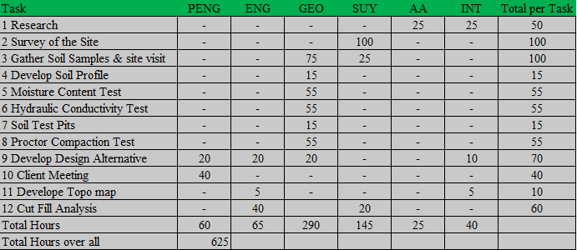

## **4.2 Cost and billing rate for Allan Lake Wetland Restoration Project**

Due to the associated costs of services and profitable income for Team Flaming Bunnies, there is an overhead (OH) per staff required to complete the project. According to our policy, an OH will be 2.5 times the base pay rate. The table below will detail the pay rate for each of the staff member:

**Table 4.2.1:** Billing Rate per staff member involved in the project.

|  |  |  |  |  |  |  |  |
| --- | --- | --- | --- | --- | --- | --- | --- |
| Classification | Base Pay ($/hr) | Benefits, % of Base Pay | Actual Pay ($/hr) | OH, % of Base Pay | Actual Pay with OH ($/hr) | Profit, % of Actual pay with OH | Billing Rate ($/hr) |
| PENG | 65 | 30 | 84.5 | 97 | 148 | 10 | 163 |
| ENG | 35 | 50 | 53 | 76 | 80 | 10 | 88 |
| GEO | 18 | 45 | 26.2 | 82 | 41 | 10 | 45 |
| SUY | 26 | 40 | 36.4 | 87 | 59 | 10 | 65 |
| AA | 18 | 80 | 32.4 | 47 | 41 | 10 | 45 |
| INT | 12 | 5 | 12.6 | 122 | 27 | 10 | 30 |

The last table will detail the cost associated to each of the staff position necessary to complete the project along with the total cost to complete the project:

**Table 4.2.2:** Total cost associated with completing the project.

|  |  |  |  |  |
| --- | --- | --- | --- | --- |
| 1.0 Personnel | Classification | Hours | Rate, $/hr | Cost |
|  | PENG | 40 | 163 | $6,520 |
|  | ENG | 90 | 88 | $7,920 |
|  | GEO | 275 | 45 | $12,375 |
|  | SUY | 110 | 65 | $7,150 |
|  | AA | 50 | 45 | $2,250 |
|  | INT | 70 | 30 | $2,100 |
|  | Total personnel | 635 | 436 | $38,315 |
| 2.0 Travel | 5 meetings @ 55 mi/meeting | $0.5/mi |  | $ 140 |
|  |  |  |  |  |
| 3.0 Expenditures | Laboratory Space | $25/hr |  | $6,875 |
|  | Surveying Equipment/Materials | $30/hr |  | $3,300 |
| **4.0 TOTAL** |  |  |  | **$48,600** |

# References

[1] T. Runyon. (2016, September 6). *Allan Lake Statement of Work* [Online]. Available email:

[tarunyon@fs.fed.us](mailto:tarunyon@fs.fed.us) Message: Introduction.

[2] US Forest Service United States of Department of Agriculture (2016). *Allan Lake Wet Rest*

*Decision Memo Final*. [Online]. Available Telnet: <http://www.fs.usda.gov/> Directory: Allan Lake Wetland Restoration Project: Decisions

[3] US Forest Service United States of Department of Agriculture (2016). *Decision Cover Letter*.

[Online]. Available Telnet: <http://www.fs.usda.gov/> Directory: Allan Lake Wetland Restoration Project: Decisions

[4] Google Earth. (2016). *Allan Lake Google Earth* [Online] Available: FTP:

<https://www.google.com/earth/>

# Appendices

**Appendix A**- Location of Allan Lake on Google Earth [4]

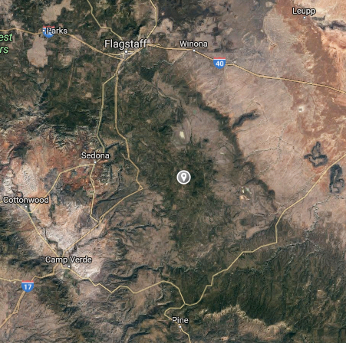

Appendix Figure A1: Allan Lake location.

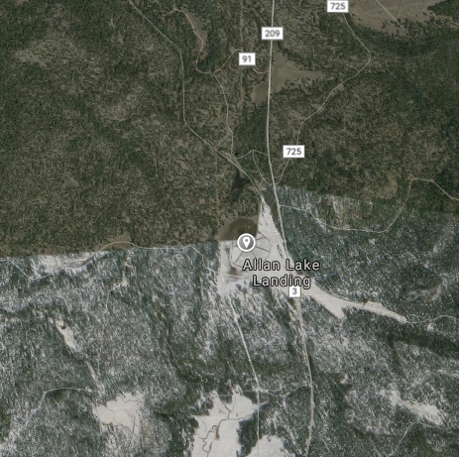

Appendix Figure A2: Allan Lake location.

**Appendix B-** Arial View of the Trenches of Allan Lake

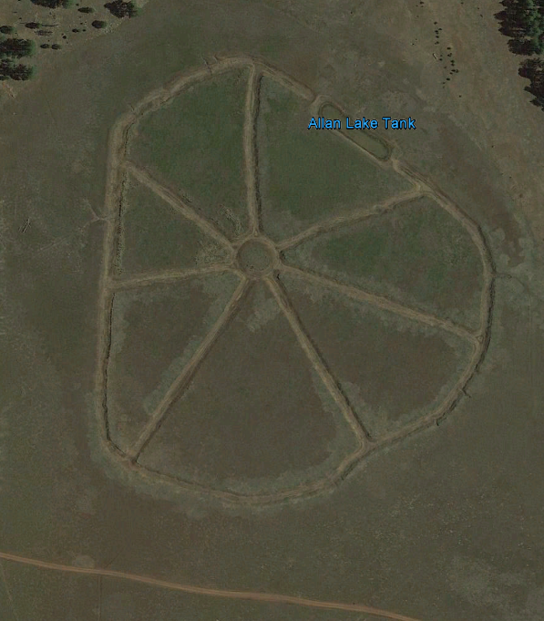

Appendix Figure B1: View of trenches of Allan Lake.

**Appendix C**- Current landscape of the project

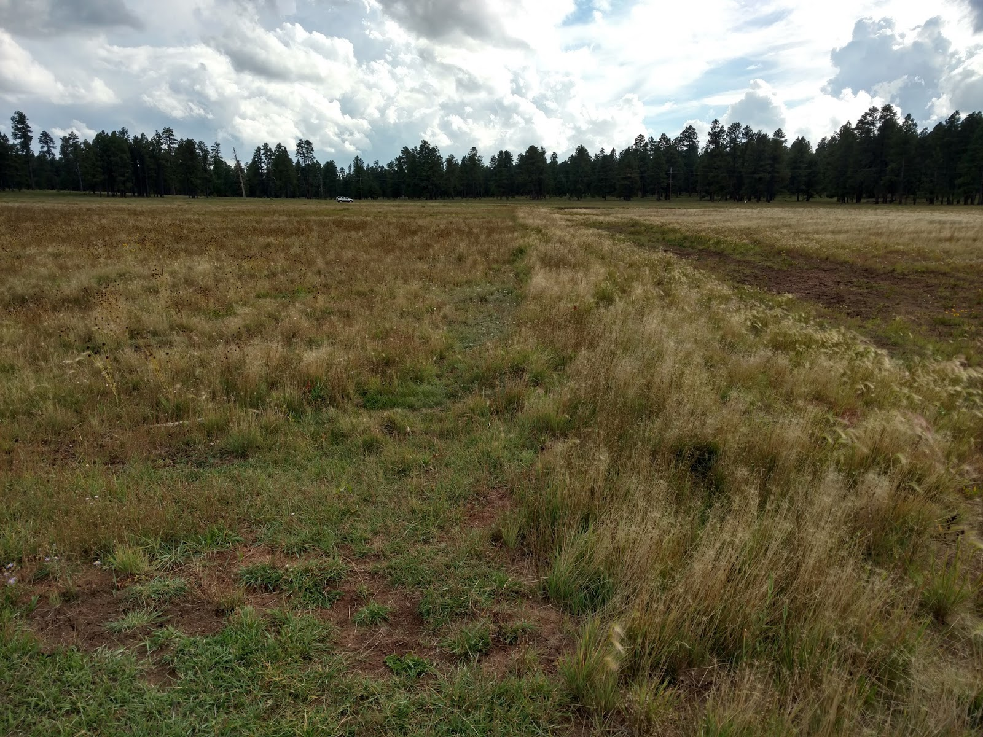

Appendix Figure C1: Differences of Vegetation

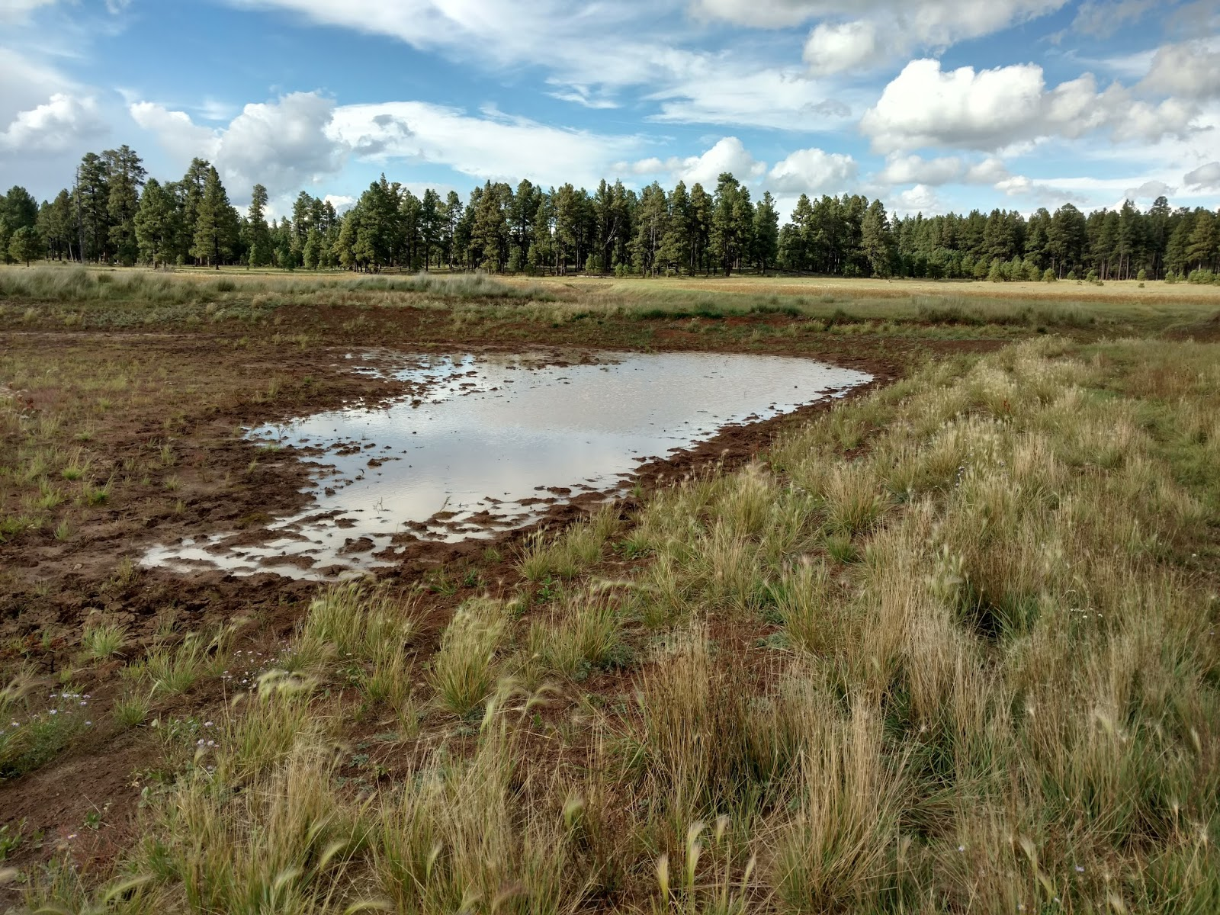

Appendix Figure C2: Small puddle of water at the project site that has undergone some restoration.

**Appendix D-** GANTT chart & Critical Path for Allen Lake Restoration

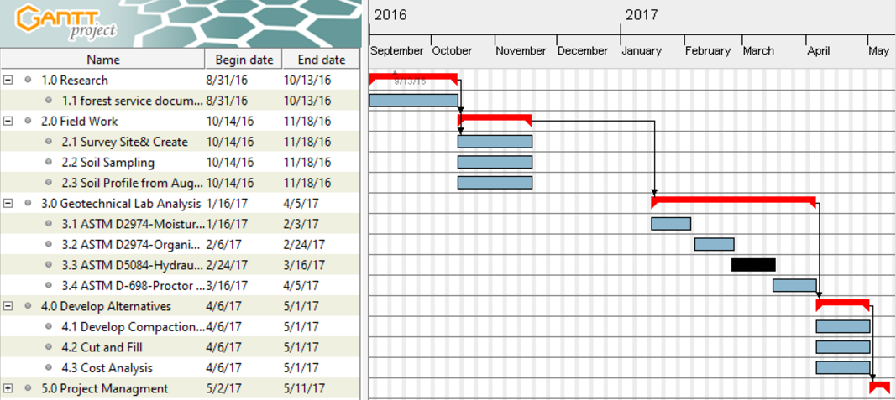

Appendix Figure D1: GANTT schedule for design analysis.

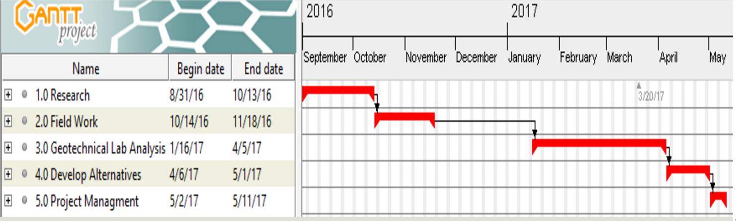

Appendix Figure D2: Critical path for the design analysis.